Information Framework (SID)
Addendum 1BT - Common Business Entity Definitions – Base Types

GB922 Addendum 1BT
TM Forum Approved Version 4.5


September, 2011

Notice
This material, including documents, code and models, has been through review cycles; however, due to the inherent complexity in the design and implementation of software and systems, no liability is accepted for any errors or omissions or for consequences of any use made of this material.
Under no circumstances will the TM Forum be liable for direct or indirect damages or any costs or losses resulting from the use of this specification. The risk of designing and implementing products in accordance with this specification is borne solely by the user of this specification.
This material bears the copyright of TM Forum and its use by members and non-members of TM Forum is governed by all of the terms and conditions of the Intellectual Property Rights Policy of the TM Forum (http://www.tmforum.org/Bylaws/1094/home.html) and may involve a claim of patent rights by one or more TM Forum members or by non-members of TM Forum.

Direct inquiries to the TM Forum office:
240 Headquarters Plaza,
East Tower – 10th Floor,
Morristown, NJ 07960 USA
Tel No. +1 973 944 5100
Fax No. +1 973 944 5110
TM Forum Web Page: www.tmforum.org

Table of Contents
Notice 2
Table of Contents 3
Table of Figures 4
1. Business Entities 5
1.1. Base Types 5
1.1.1. TimePeriod 7
1.1.2. Example 9
1.1.3. Notes: 10
1.1.4. References 11
1.1.5. Standard citation for this document 12
1.2. Base Entities (Value Classes) 13
1.2.1. Time Period 13
1.2.2. Duration 14
1.2.3. Quantity 15
1.2.4. Money 16
1.2.5. Rate 17
1.2.6. CostRate 18
1.2.7. TimeUnit 19
2. Administrative Appendix 21
2.1. About this document 21
2.2. Document History 21
2.2.1. Version History 21
2.2.2. Release History 22
2.3. Company Contact Details 22
2.4. Acknowledgments 23

Table of Figures

fig 1a – Base Types 7
fig 2 – Point – Interval Relations 8
fig 2 – Interval – Interval Relations 9

Business Entities

Base Types
This document covers base types that have been found to be useful during the documentation of the SID business models.
Standard types like String, Integer etc are not covered as these are usually provided by commonly used programming languages.
It is not intended to define simplistic restricted fundamental types like String(7) or Number(3).
These Base Types are not intended to have their own identity (they don’t have an id like a Managed Entity). This means that these entities would not normally be shared, but would be private attributes of an entity.
Fowler defines entities like these as “value objects”, which he defines as:
“A small simple object, like money or a date range, whose equality isn't based on identity” [Fowler-PoEAA]

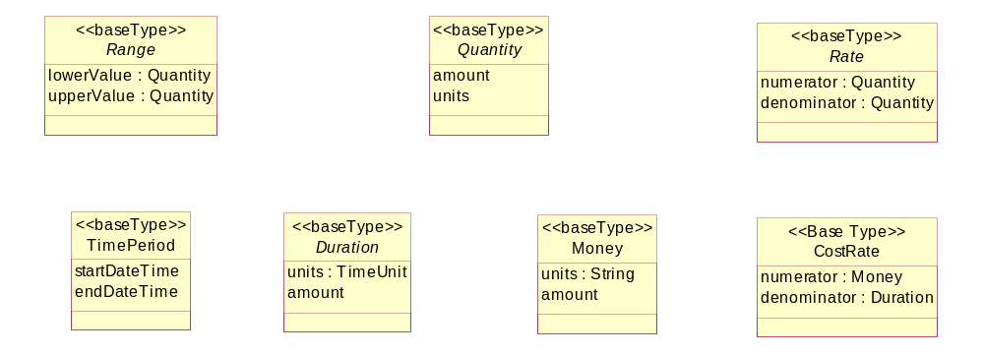
fig 1a – Base Types

TimePeriod
The TimePeriod class looks simple, but covers a surprising amount of functionality
For example, we would need to be able to compare the time interval with a point of time
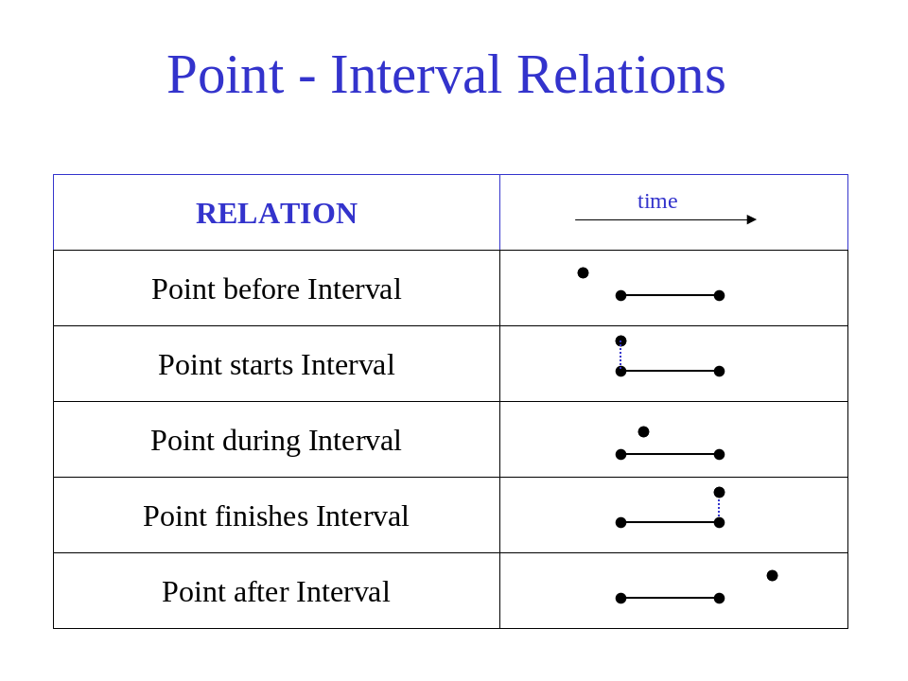
fig 2 – Point – Interval Relations

Also, we will want to be able to compare time intervals.
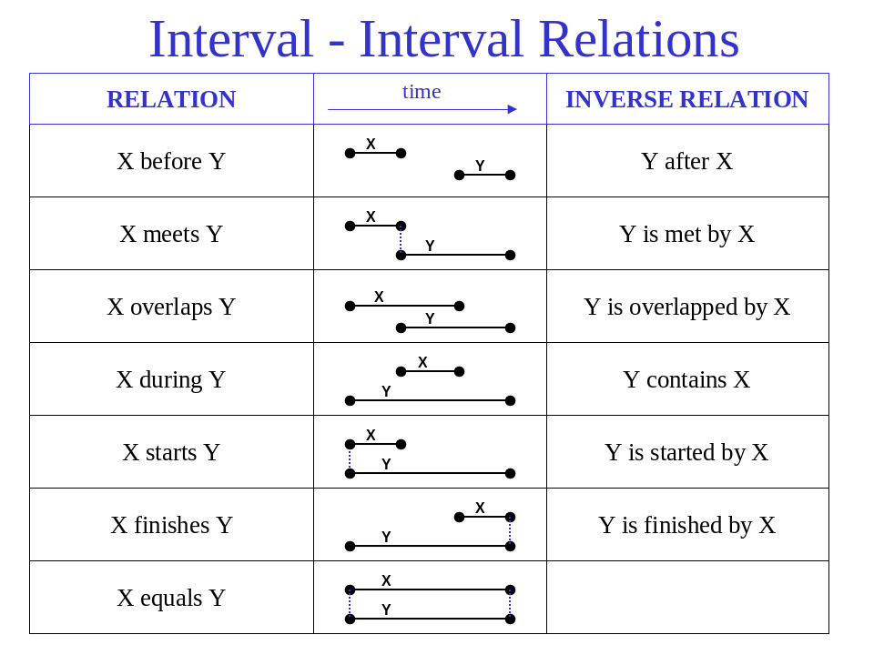
fig 2 – Interval – Interval Relations
Having this functionality in the TimePeriod entity means that it can be reused across the SID.
A good paper to read on time intervals (based on Allen’s interval algebra) are [graph1] and [graph2].

Example
Here is a non-telco example of use of the base types.
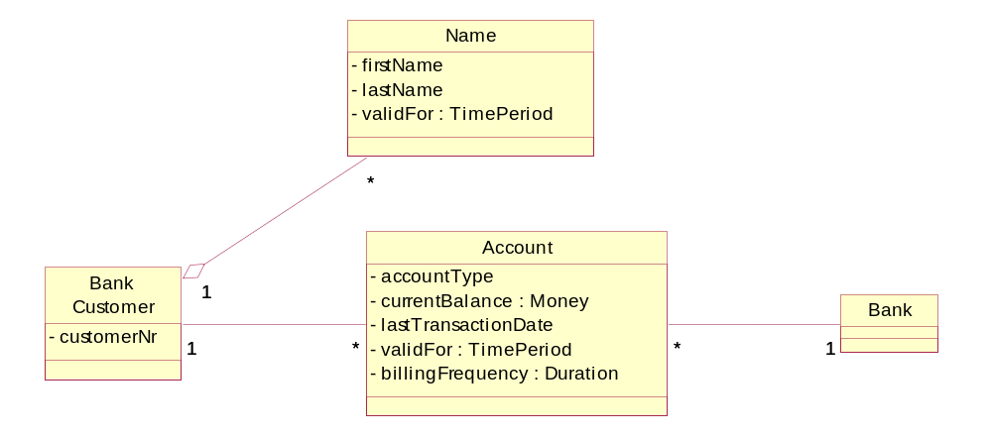
Our simple example shows the following example situation.
- A bank models its customers , their names & accounts
- A bank customer can have many names over time (but maybe only one name at any one time)
- The bank has many customers.
- Customers of the bank have accounts. A single customer can have many accounts.
- The account has a current balance, e.g. $US15, 000 or £3,400
- The account was opened on 1998/02/01 and has not been closed (validFor)
- Bills are sent out based on the billing frequency (e.g. every 3 months)

Notes:
- Note that these entities represent business concepts in a Service Provider that conforms to the eTOM process model [eTOM].
- Entities that are outside the scope of this model facet are shown with a white fill color.
- This is intended as a “minimalist” model. Subtypes and attributes should be added as required. The attributes shown should be considered as suggested, not required.
- Parent attributes are not repeated in the sub entities
- In most cases relationships are not documented as attributes
- Only significant entities are shown in the “related business entities” cells

References
Fowler-AP | Analysis Patterns – Reusable Object Models by Martin Fowler ISBN 0-201-89542-0  http://martinfowler.com/articles.html
Fowler-Time | Patterns for things that change with time http://martinfowler.com/ap2/timeNarrative.html  Effectivity http://martinfowler.com/ap2/effectivity.html
Fowler-Range | Range http://martinfowler.com/ap2/range.html
Larman | Applying UML and Patterns, Second Edition, ISBN 0-13-095004-1  http://www.craiglarman.com/book_applying_2nd/Applying_2nd.htm
ISO 8601 | ISO 8601:2000 : Data elements and interchange formats – Information interchange – Representation of dates and times
ISO 1000 | ISO 1000:1992 : SI units and recommendations for the use of their multiples and of certain other units
ISO 11404 | ISO/IEC 11404:1996 : Information technology – Programming languages, their environments and system software interfaces – Language-independent datatypes
ISO 31-0 | ISO 31-0:1992 : Quantities and units; part 0: general principles
ISO 31-1 | ISO 31-1:1992 : Quantities and units; part 1: space and time
ISO IS/19108 | IS 19108, Geographic information – Temporal schema
OMG Currency | Currency Specification – Specifies a set of business objects and related abstractions as a proposed standard to support international currency  http://www.omg.org/technology/documents/domain_spec_catalog.htm
Duration Theory | Process Specification Language Ontology - Duration Theory  http://www.mel.nist.gov/psl/psl-ontology/part13/duration.th.html
UBL | Universal Business Language (UBL) Date and Time Representation Position Paper 5, 26 March 2003, Stuhec & Adcock  http://www.oasis-open.org/committees/ubl/ndrsc/current/p-stuhec-datetime-05.doc
Fowler-PoEAA | Patterns of Enterprise Application Architecture, ISBN 0-321-12742-0  http://www.martinfowler.com/books.html - eaa
iCalendar | Internet Calendaring and Scheduling Core Object Specification (iCalendar), F. Dawson, D. Stenerson  http://www.ietf.org/rfc/rfc2445.txt
graph1 | M. Beaumont, A. Sattar, M.J. Maher & J. Thornton, Solving Overconstrained Temporal Reasoning Problems, Proc. Australian Joint Conference on Artificial Intelligence, 37-49, 2001.  http://www.math.luc.edu/~mjm/pubs/
graph2 | Extending the Point Algebra into the Qualitative Algebra, Andrei Krokhin, Peter Jonsson  http://www.computer.org/proceedings/time/1474/1474toc.htm

Standard citation for this document
TeleManagement Forum SID GB922 Addendum 1BT (Base Types)
Chris Hartley et al.
URL: http://www.tmforum.org/

Base Entities (Value Classes)

Time Period

Business Entity Definition
Business Entity Name | TimePeriod
Description | A base / value business entity used to represent a period of time, between two timepoints
Sources | [Fowler-Time], [iCalendar] | Cross- References |  |  | Synonyms / Aliases | Time Interval, Time Span, Period of Time
Related Business Entities
Business Rules | Time Period is a value entity and does not have any business identity

Business Entity Attributes Definition
Business Entity Name | TimePeriod
Attribute Name | Description | Data Type | Characteristics, Permitted Values & Units | Required/  Optional | Notes
startDateTime | An instant of time, starting at the TimePeriod | Date/Time |  | Optional | If null, then represents to the beginning of time
endDateTime | An instant of time, ending at the TimePeriod | Date/Time |  | Optional | If null, then represents to the end of time

Duration

Business Entity Definition
Business Entity Name | Duration
Description | A base / value business entity used to represent a length of time.  Duration is a type of Quantity
Sources | [Fowler-Time], [iCalendar] | Cross- References |  |  | Synonyms / Aliases | Length of Time
Related Business Entities | Quantity
Business Rules | Duration is a value entity and does not have any business identity

Business Entity Attributes Definition
Business Entity Name | Duration
Attribute Name | Description | Data Type | Characteristics, Permitted Values & Units | Required/  Optional | Notes
amount |  | Number |  | Required | A positive floating point number
units |  | TimeUnit |  | Required | Unit would be milliseconds, seconds, minutes, hours, days, weeks, months or years

Quantity

Business Entity Definition
Business Entity Name | Quantity
Description | A base / value business entity used to represent measurements.
Sources | [Fowler-AP] | Cross- References |  |  | Synonyms / Aliases
Related Business Entities
Business Rules | Quantity is a value entity and does not have any business identity

Business Entity Attributes Definition
Business Entity Name | Quantity
Attribute Name | Description | Data Type | Characteristics, Permitted Values & Units | Required/  Optional | Notes
amount |  | Number |  | Required
units |  | Unit |  | Required | e.g. metres, cubic yards, kilograms [ISO 1000]

Money

Business Entity Definition
Business Entity Name | Money
Description | A base / value business entity used to represent money
Sources | [Fowler-AP]  [Fowler-PoEAA] | Cross- References |  |  | Synonyms / Aliases
Related Business Entities | Quantity
Business Rules | Money is a value entity and does not have any business identity

Business Entity Attributes Definition
Business Entity Name | Money
Attribute Name | Description | Data Type | Characteristics, Permitted Values & Units | Required/  Optional | Notes
amount |  | Number |  | Required
units |  | Currency |  | Required | refer to [ISO 4217]

Rate

Business Entity Definition
Business Entity Name | Rate
Description | A base / value business entity used to represent the change in one quantity in terms of another
Sources | [ | Cross- References |  |  | Synonyms / Aliases
Related Business Entities | Quantity
Business Rules | Rate is a value entity and does not have any business identity

Business Entity Attributes Definition
Business Entity Name | Rate
Attribute Name | Description | Data Type | Characteristics, Permitted Values & Units | Required/  Optional | Notes
numerator |  | Quantity |  | Required
denominator |  | Quantity |  | Required

CostRate

Business Entity Definition
Business Entity Name | CostRate
Description | A base / value business entity used to represent a cost per time unit. e.g. $10/hr, 33 pence/min
Sources | [Fowler-AP] | Cross- References |  |  | Synonyms / Aliases
Related Business Entities | Quantity, Money, Duration
Business Rules | CostRate is a value entity and does not have any business identity

Business Entity Attributes Definition
Business Entity Name | CostRate
Attribute Name | Description | Data Type | Characteristics, Permitted Values & Units | Required/  Optional | Notes
numerator |  | Money |  | Required | May be positive or negative
denominator |  | Duration |  | Required

TimeUnit

Business Entity Definition
Business Entity Name | TimeUnit
Description | A base / value business entity used to represent different units of time , such as milliseconds, seconds, minutes, hours, days, weeks, months or years
Sources | [Fowler-AP] | Cross- References |  |  | Synonyms / Aliases
Related Business Entities | Quantity, Money, Duration
Business Rules | CostRate is a value entity and does not have any business identity

Business Entity Attributes Definition
Business Entity Name | CostRate
Attribute Name | Description | Data Type | Characteristics, Permitted Values & Units | Required/  Optional | Notes

Administrative Appendix
This Appendix provides additional background material about the TM Forum and this document. In general. sections may be included or omitted as desired, however a Document History must always be included

About this document
This is a TM Forum Guidebook. The guidebook format is used when:
- The document lays out a ‘core’ part of TM Forum’s approach to automating business processes. Such guidebooks would include the Telecom Operations Map and the Technology Integration Map, but not the detailed specifications that are developed in support of the approach.
- Information about TM Forum policy, or goals or programs is provided, such as the Strategic Plan or Operating Plan.
- Information about the marketplace is provided, as in the report on the size of the OSS market.

Document History

Version History
<This section records the changes between this and the previous document version as it is edited by the team concerned. Note: this is an incremental number which does not have to match the release number>

Version Number | Date Modified | Modified by: | Description of changes
0.1 | September 2002 |  | Document created. Base Types extracted from Party Document
0.5 | Dec 2002 |  | Formatted for Member Evaluation Release
1.1 | Feb 2003 |  | Phase 3 updates. Additional references & citation section added.
3.0 | April 2003 |  | Formatted for Phase 3 release
3.1 | July 2003 |  | Formatted for Member Review with NGOSS R3.5
3.2 | Aug 2004 |  | To reflect TMF Approval Status
4.0 | Mar 2008 | John Reilly | Updated based on member comments
4.1 | July 2008 | Tina O’Sullivan | Corrections prior to posting.
4.2 | May 2009 | Alicja Kawecki | Minor updates to reflect TM Forum Approved status
4.3 | December 2010 | John Reilly | Update Notice
4.4 | March 2011 | Alicja Kawecki | Minor formatting corrections prior to web posting and ME
4.5 | September 2011 | Alicja Kawecki | Updated to reflect TM Forum Approved status

Release History
<This section records the changes between this and the previous Official document release>

Release Number | Date Modified | Modified by: | Description of changes
8.0 | Mar 2008 | John Reilly | Updated based on member comments
9.5 | Dec 2010 | John Reilly | Update Notice

Company Contact Details
Company | Team Member Representative
Amdocs | Name: Josh Salomon  Title: Senior Billing architect,  Email: joshs@amdocs.com  Phone: +972 9 7764422  Fax
Progress Software | Name: John Wilmes  Title: Chief Technical Architect  Email: jwilmes@progress.com  Phone: +1 650 302 5198  Fax

Acknowledgments
This document was prepared by the members of the TeleManagement Forum SID team:
The Shared Information/Data Model is a genuinely collaborative effort. The TM Forum would like to thank the following people for contributing their time and expertise to the production of this document. It is just not possible to recognize all the organizations and individuals that have contributed or influenced the introduction. We apologize to any person or organization we inadvertently missed in these acknowledgments.
Key individuals that reviewed, provided input, managed, and determined how to utilize inputs coming from all over the world, and really made this document happen were:
Name | Affiliation
Cliff Faurer | TM Forum
Chris Hartley | Telstra
Helen Hepburn | British Telecom
John Reilly | TM Forum
Wayne Sigley | Telstra
John Strassner | Intelliden

